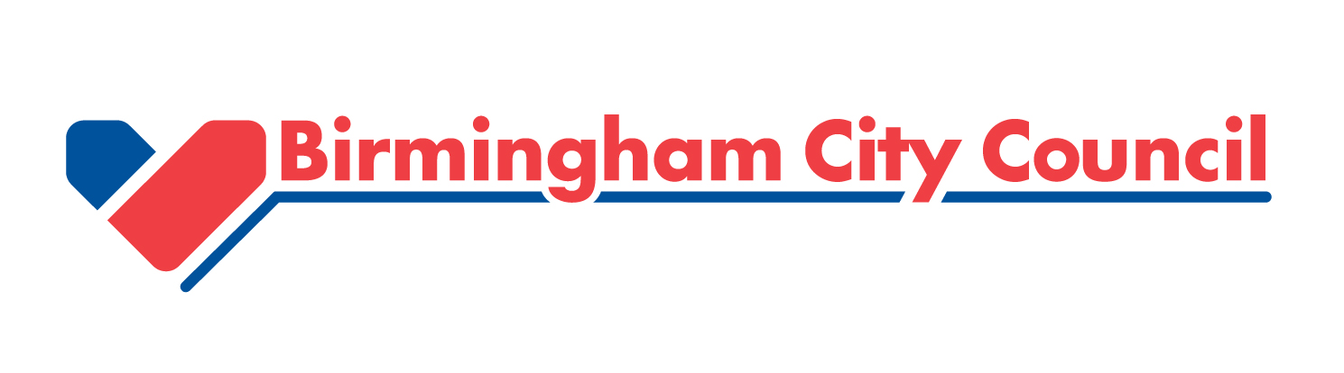

Fair Money Manifesto

Contents

Foreword 03

Commitments
- Birmingham City Council supports the call for better regulation of high cost
credit lenders 05

- We will take action to support the growth of credit unions and other forms of
more responsible lending 06

- We will call on the banks to increase the availability of responsibly provided
credit to people on low and middle incomes 07

- We will call on government to make payday and other high cost lenders
come clean about their provision in Birmingham and seek powers to restrict
their operations 08

Foreword by Cllr John Cotton, Cabinet Member for Social Cohesion and Equalities
Birmingham has tremendous strengths – its youthful population, its rich heritage and diversity, its spirit of innovation and enterprise. But we also face some real challenges. Inequalities, deprivation and poverty still hold many of our fellow citizens back. That’s why we have launched our Fair Brum campaign – to provide hope and help people change their lives for the better.
Birmingham Fair Money is a critical part of this campaign. We know that rising prices and pressure on wages is creating a cost of living crisis for many households in the city. Borrowing from payday and other high cost lenders to bridge the gap can seem like a quick solution to the shortfall between income and essential outgoings. But loans at such high cost can be extremely damaging to households, trapping them in a spiral of increased borrowing and making a bad situation much worse. There’s a wider impact on communities too. Lenders who are profiting from people’s hardship are taking millions out of our poorest neighbourhoods, sucking money out the areas that can least afford to lose it.
This manifesto sets out our four clear commitments to tackle these problems. We support calls for national changes to the regulation of high cost lenders, but crucially this manifesto focuses on what we, and our partners across Birmingham, can do ourselves. Where we have the powers to intervene and make a difference, we will use them. And where we think we need more powers from Government, for example to stop the proliferation of high cost lenders on our high streets, then we will be pro-active in calling for these to be delivered to us. This manifesto is our pledge to the citizens of Birmingham that we will do all we can – working together with partner agencies - to ensure they have access to fair, affordable, financial services in the city.

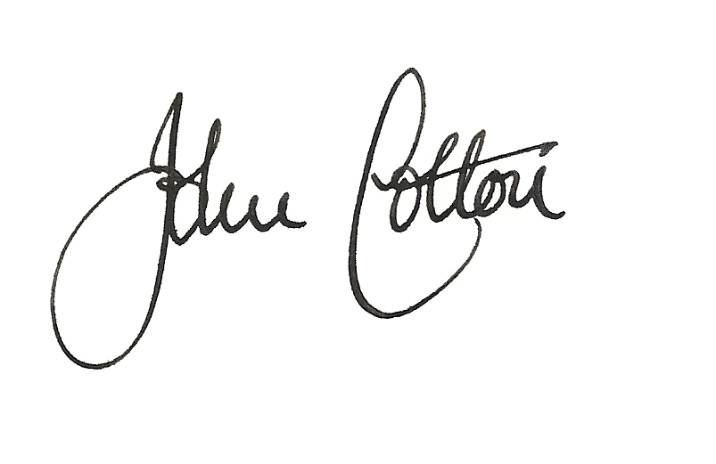
_______________________________________
Councillor John Cotton
Cabinet Member for Social Cohesion & Equalities

Our Manifesto for Fair, Affordable, Financial Services
- Birmingham City Council supports the call for better regulation of high cost credit lenders
Birmingham City Council has signed the Charter, launched by Paul Blomfield MP, to ‘stop the payday lending rip-off’. The Charter has widespread cross party support from MPs and is supported by Citizens Advice, the free debt advice agency, StepChange, Which?, and by the Centre for Responsible Credit. It calls on Government and the Financial Conduct Authority to put in place effective regulations for payday and other high cost lenders which will:
- Stop them giving loans to people who can’t realistically afford to pay them back
- Stop them repeatedly rolling over loans and creating spiralling debt
- Stop hidden or excessive charges
- Stop them raiding borrowers’ bank accounts without their knowledge and leaving them in hardship
- Stop irresponsible advertising and instead provide clear and transparent information
- Require lenders to promote free and independent debt advice, and ensure they co-operate with other services to help people get out of debt.
Birmingham City Council also supports the capping of interest rates.

As well as signing the Charter ourselves, we will actively promote it and encourage others in the city to provide their support.
- We will take action to support the growth of credit unions and other forms of more responsible lending.
We are already working with credit unions and other not for profit lenders in the city to provide an alternative to the high cost lenders. Not-for-profit lenders in Birmingham have now joined together under the brand “Birmingham Fair Money” to promote their services to residents who might otherwise resort to borrowing from the growing number of payday lenders and pawnbrokers in and around the city. The lenders that have joined the scheme so far are Citysave, MONEYLINE, Street UK and Advance Credit Union Ltd . The city council is very supportive of this initiative and is funding a pop up shop on High Street from 1st October to 24th December 2013 to provide direct competition to the high cost stores in that area in the run up to Christmas.
A permanent website, birminghamfairmoney.org.uk has been established which provides a range of financial help and advice aimed at the financially excluded.
The initial use of the pop up loans shop and web site has been very encouraging with over 1000 enquiries in the first 4 weeks through shop and web site.
We have started to work with Citysave with regards to assisting people who have defaulted on their Council Tax Direct Debit payments. The aim of this is to assess the effectiveness of how offering credit union accounts can help people to save or avoid bank charges for bounced direct debits and high overdraft fees, making it easier for them to afford to pay other priority bills, including Council Tax.
But we recognise the need to build further on this work, and moving forwards we will be looking at how we can better promote credit unions and other not for profit lenders to our employees and service users. We have already started to make progress with employees in our electronic internal communications but plan to do more in the coming year. We will publish further details of how we will do this by March 2014.
- We will call on the banks to increase the availability of responsibly provided credit to people on low and middle incomes.
During the passage of the Financial Services Act 2012, Government made a commitment to ensure that banks and other lenders disclose details of their lending patterns at the local, postcode, level. We now understand that data will be available from the main banks and from Nationwide Building Society by the end of this year.
We are committed to working with our academics to analyse this information, alongside indicators of financial hardship, to provide a detailed picture of financial services provision in Birmingham. We will use this analysis to identify how the main banks could help us improve access to fair, affordable, financial services and will invite the senior management of the major banks to meet with us to discuss how this can be taken forwards – either directly, for example by the banks increasing access to low cost accounts and loans for people on low incomes, or indirectly by scaling up their investment in local not for profit financial services providers.

- We will call on Government to make payday and other high cost lenders to come clean about their provision in Birmingham and seek powers to restrict their operations.
We will also call on Government to ensure that any disclosure of lending patterns is extended to the payday and high cost lenders, so that we can properly assess the extent of the problems in our city. But knowing the scale of the problem has to be combined with additional powers to help us stop its further expansion. We have already taken action to restrict the advertising of, and access to high cost lenders via our public computer systems, for example in our libraries. We now wish to go beyond this, and look at how we can, through the planning system, also halt the proliferation of high cost lenders on our high streets. To do this, we need Government to provide us with a licensing function for high cost credit businesses. This would allow us to consider the likely impacts of any more high cost credit outlets on our communities before any more are opened. Our proposed aims for this licensing function are:
- To prevent the use of high cost credit from impacting negatively on local economic growth;
- To ensure that trading is done in a fair and honest way;
- To protect vulnerable groups of residents from being harmed or exploited by high cost credit lenders.
- To prevent the proliferation or “clustering” of outlets in localities

To take this forwards we will be writing to the Department for Communities and Local Government and to the Local Government Association and ask them to convene a meeting with local authorities to discuss how a licensing function for high cost credit could be delivered.
If we are granted this licensing function then we will pro-actively monitor the compliance of high cost lenders with the law and will take steps to ensure that only those operating responsibly are able to trade in our city.
